**PROJECT REPORT**

NETFLIX ANALYSIS

**Name** – Shaikh Aman Hashim

**Project Title** – Netflix Analysis

**Date** – 8 Jan 2025

**Technology** – Tableau

**Project Description:**

This project aims to analyze Netflix's content library and trends using Tableau. By leveraging visual analytics, we uncover insights about content distribution, genre popularity, release trends, and regional availability. The dataset includes details such as movie and TV show titles, release years, genres, ratings, and country of production.

**Objective:**

The objectives of this Netflix analysis project include:

* Understand the distribution of content across different genres and formats (Movies vs. TV Shows).
* Identify trends in content production over the years.
* Analyze content ratings and their distribution.
* Determine country-wise content availability.
* Gain insights into the most frequent actors and directors in Netflix’s library.

**Key Performance Indicators (KPIs):**

#### ****1.**** Total Number of Titles

* Measures the total count of movies and TV shows available on Netflix.

• Helps understand the platform’s content volume..

#### ****2.**** Movies vs. TV Shows Ratio

* Percentage breakdown of movies and TV shows.
* Helps identify whether Netflix focuses more on movies or series.

#### ****3.**** Content Ratings Distribution

* Breakdown of TV and movie ratings (e.g., TV-MA, PG-13, R).

#### Useful for audience segmentation and content targeting.

#### ****4. Top 10 Directors****

* Identifies the most featured filmmakers and cast members on Netflix.
* Useful for talent analysis and content collaborations.

#### 5. Top 5 Most Popular Content Types (Based on Count

* Identifies the most frequently occurring content formats (e.g., documentaries, stand-up specials).
* Useful for understanding audience preferences

### ****Data Summary:****

* **Data Source:** It includes metadata related to movies and TV shows.
* **Key Data Fields:**
* **Show ID** – A unique identifier for each title.
* **Title** – Name of the movie or TV show.
* **Type** – Classification as a "Movie" or "TV Show".
* **Director** – Name(s) of the director(s).
* **Cast** – List of actors featured in the content.
* **Country** – The country where the content was produced.
* **Data Volume:** The dataset contains **thousands of records**, covering content from multiple countries.

The data spans multiple years, with a focus on recent additions.

#### ****Key Graphs and Visualizations:****

1. **Total Title:**

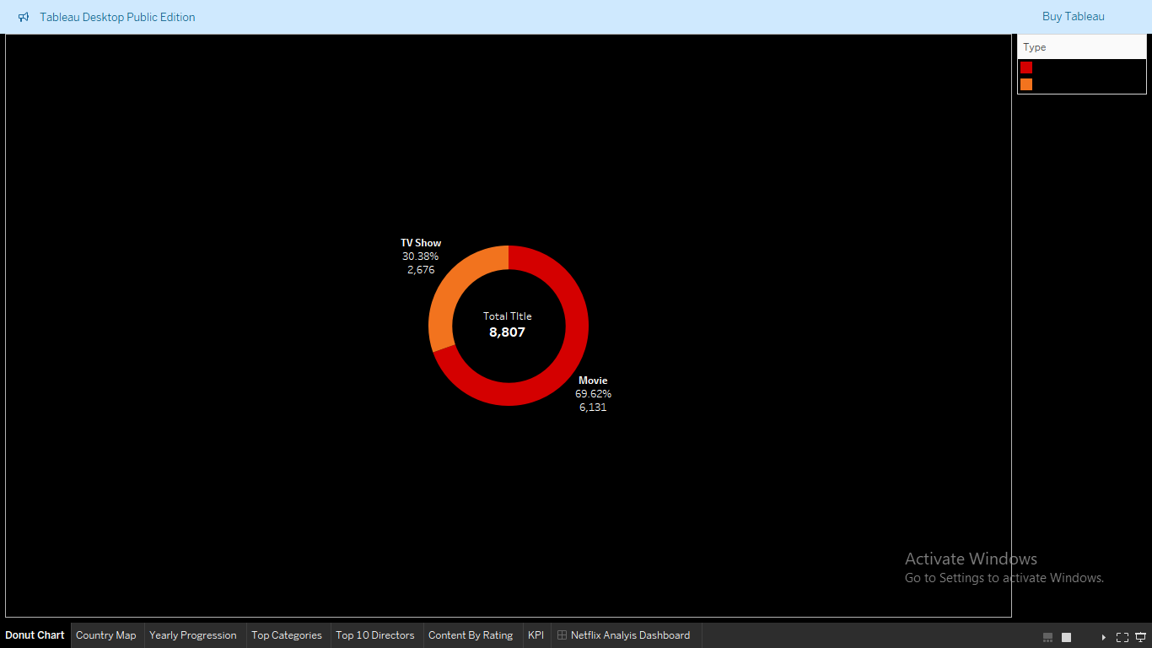

• Netflix has a significantly higher number of movies compared to TV shows.

• The platform’s focus leans towards movie content, while TV shows form a smaller share.

• The ratio helps in understanding Netflix's content strategy.

1. **Country map:**

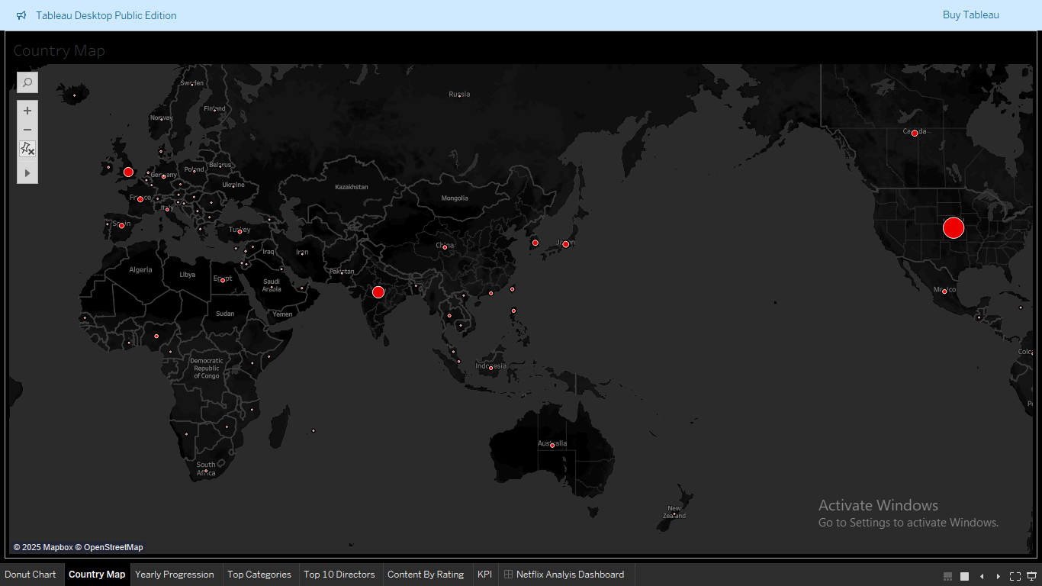

* Countries with the highest number of Netflix titles.
* Darker shades (for a choropleth map) or larger circles (for a symbol map) indicate a higher number of titles.

1. **Top 5 categories:**

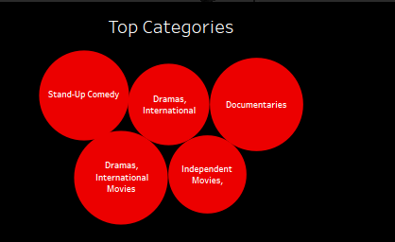

* The top 5 most frequent genres in Netflix’s catalog.
* Example genres: **Drama, Comedy, Documentary, Action, Thriller**.

1. **Yearly Progression:**

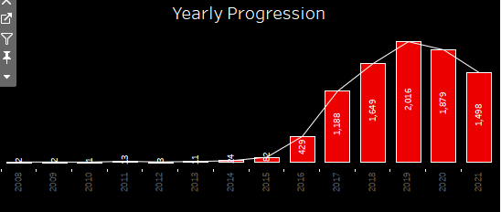

* + Displays the number of titles added to Netflix each year.
  + Differentiates between **Movies and TV Shows** using color segmentation.
  + The yearly progression is 14 year difference between 2008 to 2021.

1. **Top 10 Directors:**

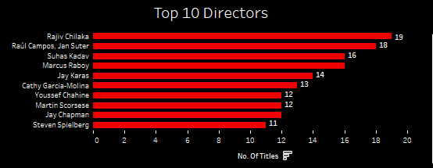

* Identifies the most featured filmmakers and cast members on Netflix.
* Useful for talent analysis and content collaborations.

1. **Content by Rating:**

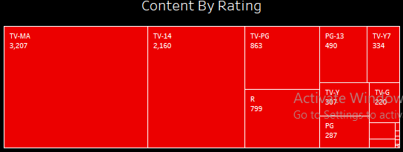

* Breakdown of TV and movie ratings (e.g., TV-MA, PG-13, R).

#### Useful for audience segmentation and content targeting.

**Key Observations from Analysis:**

* **Netflix’s Content Library Dominated by Movies:** Out of **8,807 total titles**, **Movies (6,131 titles, ~70%)** make up a significantly larger portion compared to **TV Shows (2,676 titles, ~30%)**.
* **Study Growth in content over the years:** A **Yearly Progression Bar Chart** shows that Netflix has consistently increased the number of titles available on the platform.
* **Drama & comedy are the most popular genres:** The **Top 5 Genre Categories Bar Chart** shows that **Drama and Comedy** dominate Netflix’s catalog.
* **Content Rating:** A **Content Ratings Analysis** reveals that a large portion of Netflix’s content is rated **TV-MA and R**, indicating a focus on mature viewers.
* **Most Frequent Director:** This helps in understanding Netflix’s partnerships with filmmakers and actors.

**Screenshot of Dashboard:**

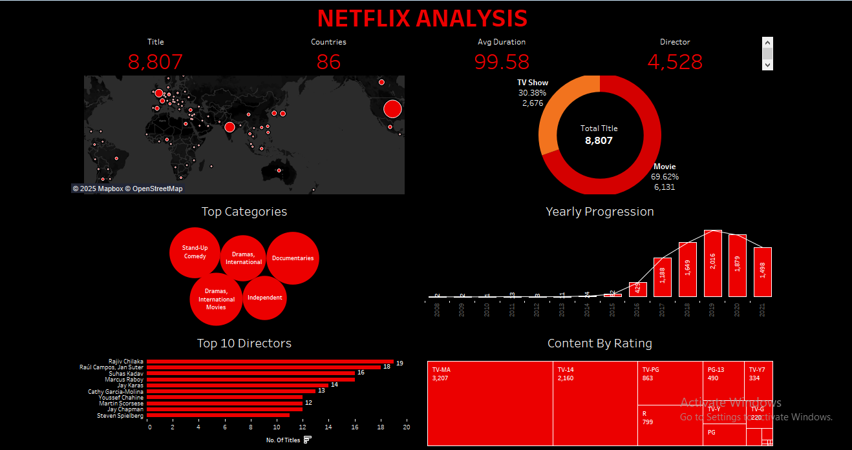

### ****Recommendations:****

1. **Increase Investment in TV Shows:**

* Netflix should **expand its TV show library** to attract binge-watchers and long-term subscribers.

1. **Diversify Content Production Beyond the USA & India:**

* **Observation:** The **USA and India** dominate Netflix’s content catalog.
* **Recommendation:** Invest in **localized content** from **Europe, Latin America, and Africa** to reach a wider global audience.

1. **Expand into Emerging Genres:**

* **Drama and Comedy** are the most dominant genres, while some niche genres remain underrepresented.

1. **Balance Content Ratings for All Audiences:**

* **Increase family-friendly content** (PG and G ratings) to attract younger audiences and families.

1. **Enhance Content Strategy with More Originals:**

* Continue investing in **exclusive Originals** to maintain a competitive advantage.
* Focus on **high-budget productions and collaborations** with top creators.

**Conclusion:**

Creating a Tableau dashboard for Netflix movies and TV shows is an effective way to explore the vast content library and make informed decisions about what to watch. By employing best practices in dashboard design, such as simplicity, consistency in colors and fonts, and choosing the right visualizations, the dashboard can present the data in an engaging and visually appealing manner. Overall, the dashboard serves as a valuable tool to understand Netflix’s content trends and user preferences, ultimately enhancing the viewer’s streaming experience.